Working document (February 2019)

University of York:

583/983 Best Practice

The University of York Library is committed to categorise its collections to inform, review and prioritise library actions and resources.

Currently we use MARC tag 583 and 983 on bibliographic records, and the Internal note 2 field in item records to mark the title and item with one of our categories (i.e. Heritage, Legacy, Self-Renewing and Finite). The tag 583 is currently not visible in YorSearch.

Example of a current bibliographic record 9944168690001381:
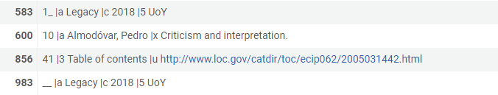
And its item record:
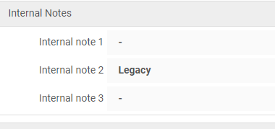

We can interpret internally each of the tags we use, however they are not descriptive enough to other institutions. This becomes an issue especially when we share our bibliographic data, as other institutions would not understand what these labels mean.
Therefore, we need to review the description used in our tagging to make it clear to other what we have decided to do with each monograph title.

Examples from other institutions

EAST Institutions
The Eastern Academic Scholars' Trust (EAST) is a shared print initiative involving 60 academic and research libraries in 11 states from Maine to Florida. EAST is focused on retaining unique, scarcely held and frequently used scholarly monographs and serials in support of scholarship, research and teaching.
Their best practice is described in this paper. Their data is shared on OCLC

They tag their monographs according to the table below:

Marc Tag 583 | Value | Notes
Indicator 1 | 1 | First Indicator-Privacy: For print archiving purposes, the default value of the first indicator should be “1” i.e., not private.
Indicator 2 |  | Indicator 2 is blank
subfield a | committed to retain | Action
subfield c | 20160630 | Date action taken, YYYYMMDD (Required)
subfield d | 20310630 | Action Interval. In this case the end date of the retention commitment
subfield f | EAST | Authorization: Archiving program
subfield u | http://eastlibraries.org/retained-materials | link to program documentation for print archiving program identified in subfield f
subfield 5 | {marc organization code} | Archiving institution, controlled terms using MARC organization code:  https://www.loc.gov/marc/organizations/org-search.php
EAST also recommends when exporting MARC records without attached holdings or item records that the 583 data be included in a 983 field.

University of Leeds
- Retention decision marked in 583: ‘Committed to retain’
- The basis of the retention decision (e.g. Heritage) entered into 983.

Questions
- Does it matter if the tag information is in a context of a consortium or simply for information to other institutions?
- None of our current 583 tags are visible on Copac, World, Yorsearch
- What context will these tags used? Who will need them? What is the driver behind the change?
- Consistency is an issue. Already there is divergence on the wording. Should we wait until there is wider UK consensus?
- Proposal at York for 583 1# a
  - ‘Retain in perpetuity’ = Heritage
  - ‘Committed to retain’ = Legacy
  - ‘High demand’ = Self renewing
  - ‘Relegate’ = Finite
Duplicate the information on a 983 tag, without making any changes.

- Alternatively, ‘committed to retain’ could be used for Heritage, Legacy and Self- Renewing’, but need to find a way to record our tags (for our own collection management purposes) - could subfield #e (Contingency for action) be used to record them?
- Another option would be to mark only heritage items as ‘committed to retain’.
- Recording Time /date of action (#c) and Action interval (#d)
  - Is the year enough in #c?
  - Do we need to start recording dates in #d?

For reference
OCLC information on field ‘583 Action Note’: https://www.oclc.org/bibformats/en/5xx/583.html

MARC 21 information on field ‘583 Action Note’: https://www.loc.gov/marc/bibliographic/bd583.html

AGF/RE University of York library
February 2019.

